DSC 650
Final Project
Nathan Soer

Introduction
The project selected was to use the physical characteristics of diamond to predict their price. This was done by using a pipeline that moves through several different technologies, including Nifi, Hive and Hbase.

Dataset
I chose to use the diamonds dataset (attached in the appendix) from Kaggel (link). This data set contains ten columns, nine of which describe the physical characteristic of various diamonds. The last is the price of the diamond.
The goal of the pipeline is to predict the price using several of the characteristics.

Pipeline
The first step in the pipeline is ingesting the data into the cluster. To do this Nifi was used to read the data from my git hub repository (link). The flow is shown in the image below.
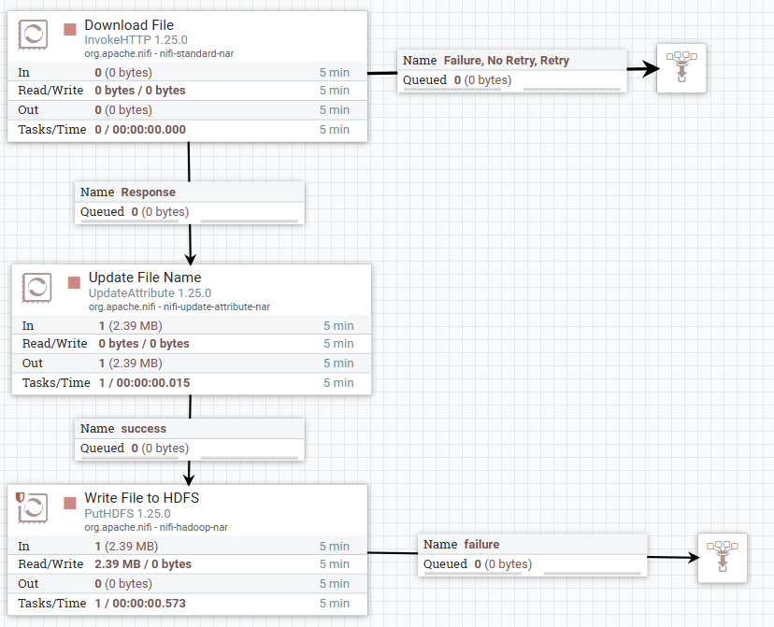
This flow consists of 3 processors. The first of which is an InvokeHTTP processor. This processor retrieves the data from the git hub repository. The next processor is an UpdateAttribute processor. It renames the file if needed. Last is the PutHDFS processor. It writes the file to the HDFS cluster.
The parameters for the various processors where configures below.
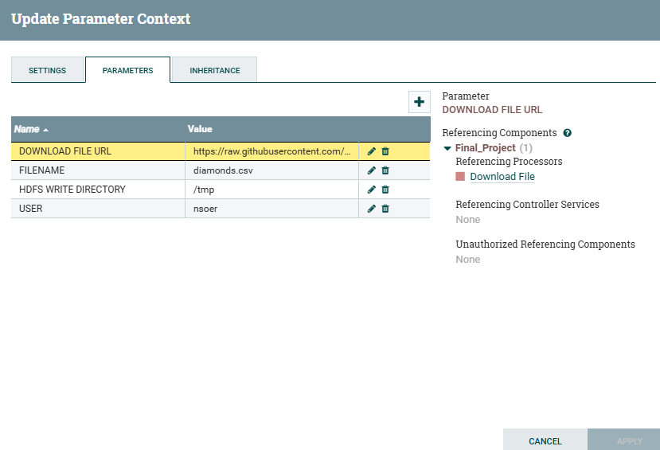
The flow was then run to place the file in the HDFS directory for further processing.
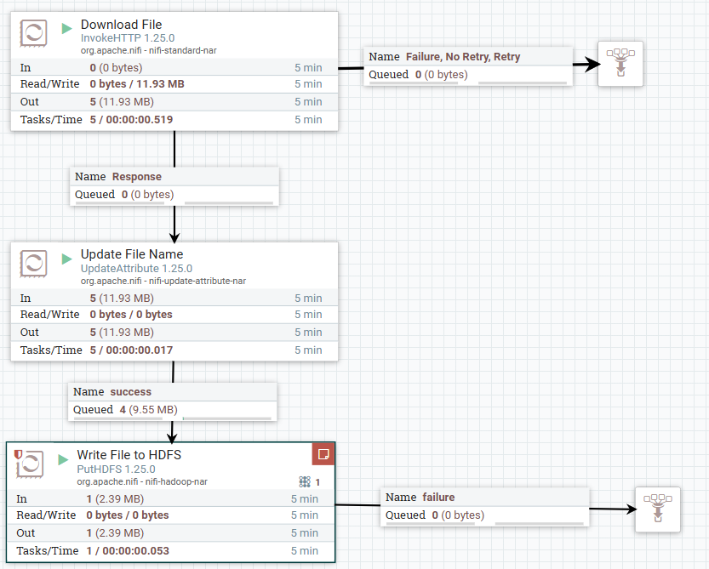
The flow was validated by checking the queues between the processors and by running a list command on the HDFS cluster for the destination directory.
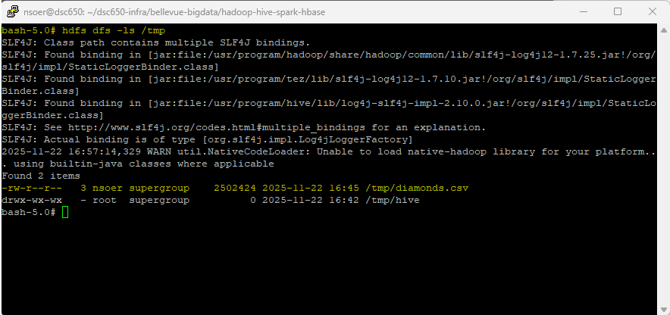

Next a Hive table was created to allow for querying of the data using SQL. The table create script is listed in the file Hive-Hbase-Spark CLI Commands that is attached in the appendix. The table was designed to mirror the file layout. One column, table, was renamed since it was a SQL keyword.
The data was next loaded into the table and verified by checking the first 10 rows.
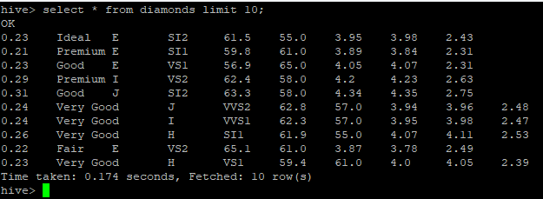
Once the data was verified to have been inserted correctly. I next ran a query to ensure that the columns were set to the correct data types by averaging any column that was numeric in nature or counting if it was not.
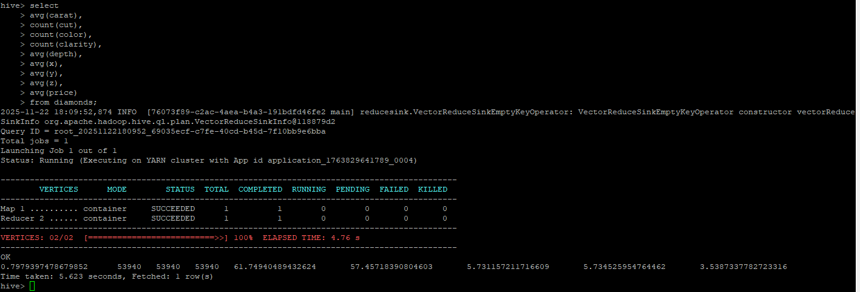

Next, I set up the python environments on all three worker nodes. The planned process for the data involves using python to perform the predictions. The numpy module that was installed is generally needed for most python applications. The other module happybase is used for writing data to HBase. I will be writing the results of the prediction to HBase.
Worker 1 install
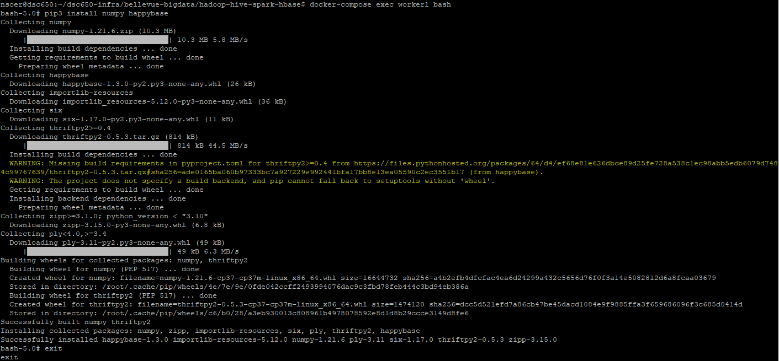
Worker 2 install
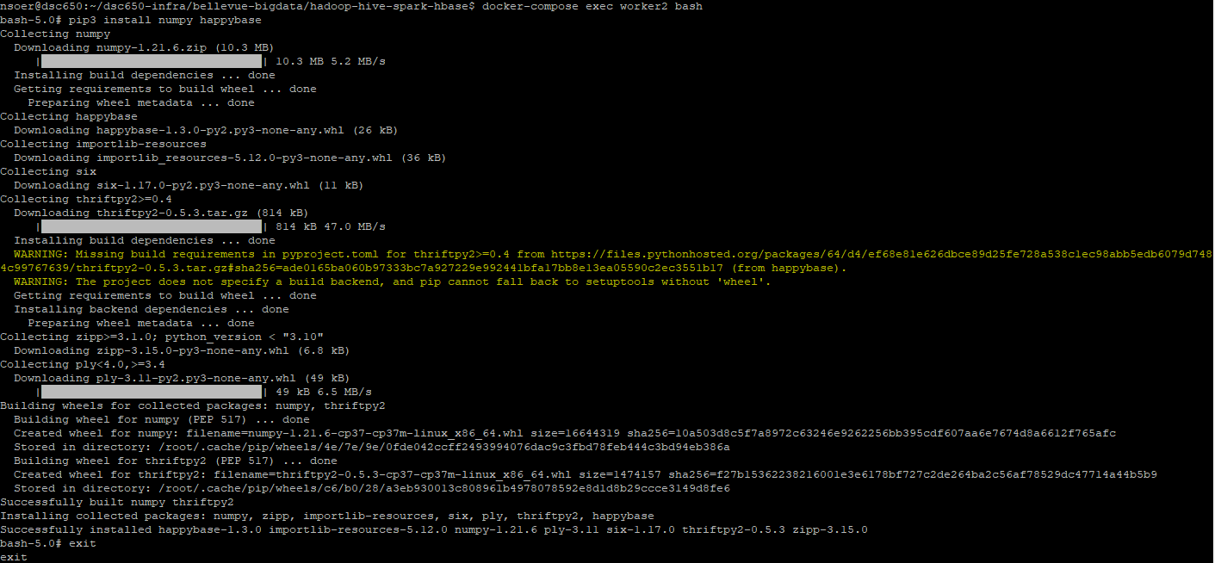
Master install
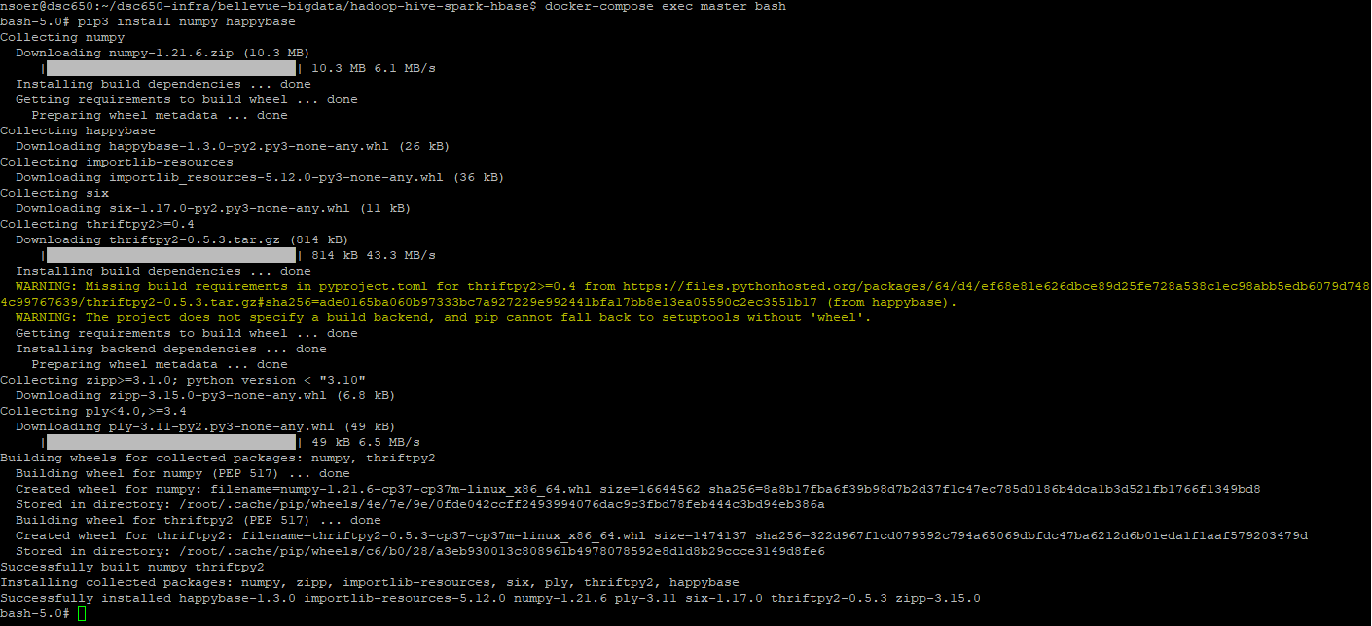
Once the modules were installed on all nodes. A thrift server was started to listen for the write requests for HBase.
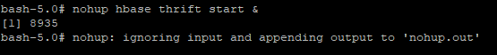

The next step was to create the destination table in HBase to store the various metrics that will be output from the prediction. The create command for the table is also listed in the file Hive-Hbase-Spark CLI Commands file.
The newly created table was scanned to ensure that it was created correctly.
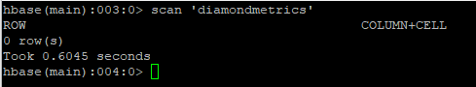
The row key is the specific run of the prediction. The column family contains the metrics used to evaluate the performance of the run.
Once the data was loaded into the Hive table and the environment was set up. I was able to run a linear regression on the data to predict the price of diamonds. I decided to only use the readily measurable features like carat, and the dimensions of the diamonds. The categorical data points in the set were created by a human judging the diamonds and are more easily mistaken. The features were then transformed into a vector for processing. Then split into training and testing data sets with 70% for training. The model was then trained on the training data set and the RMSE and R² metrics were calculated using the testing data set. The results of these metrics were written to the HBase table.
The python code can be found in the Project.py file in the appendix. The python code was submitted to spark using the below command.
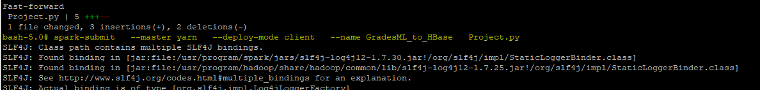
Samples of the output logs are below.
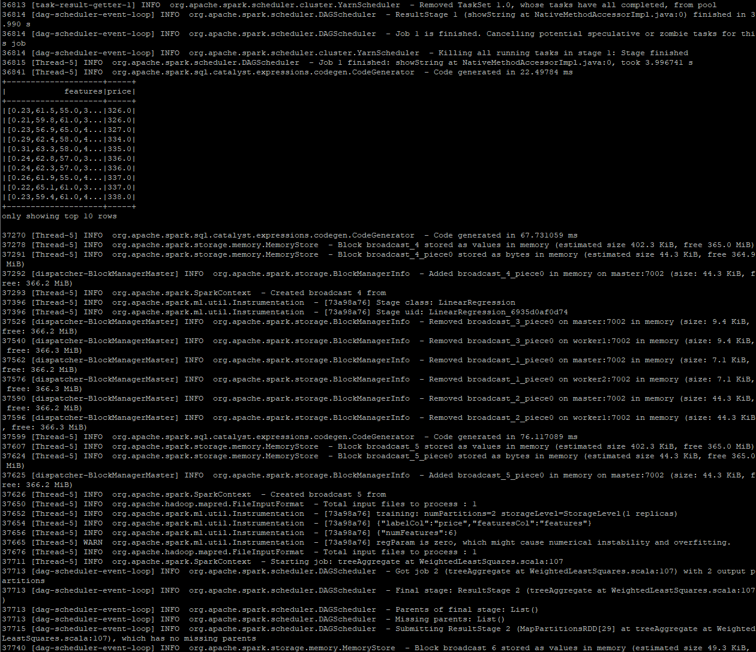
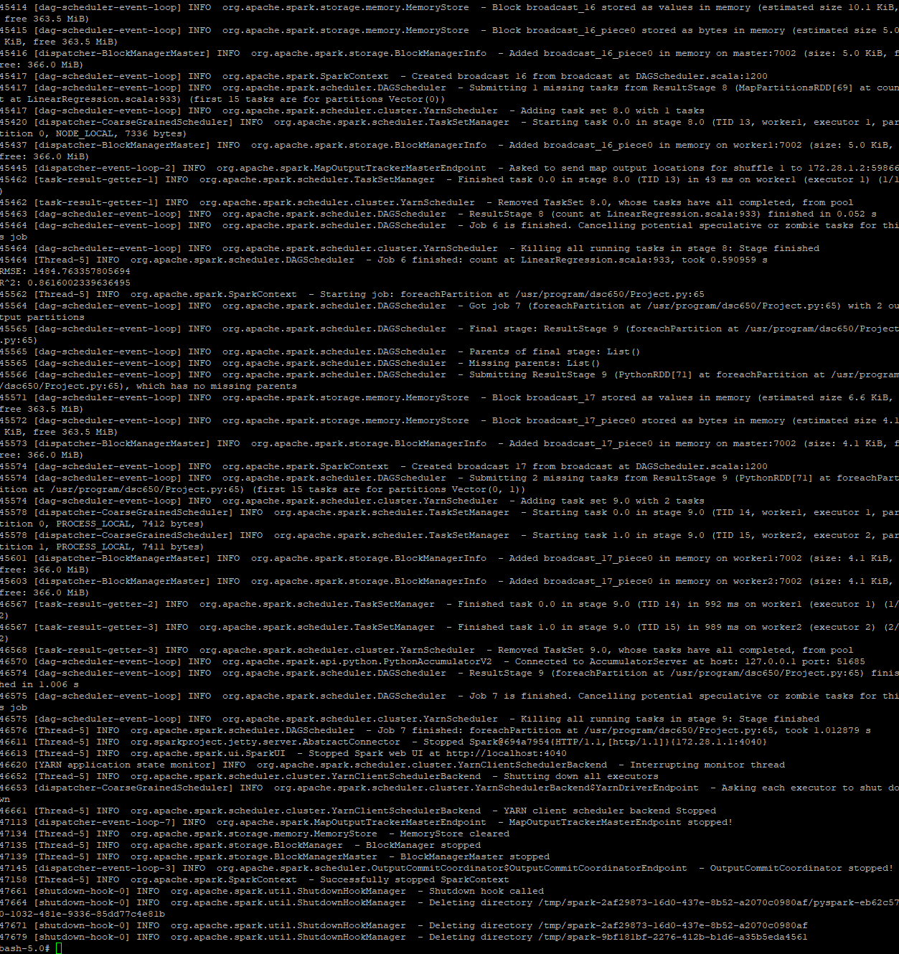

Finally the results of the regression analysis were reviewed in the HBase table.
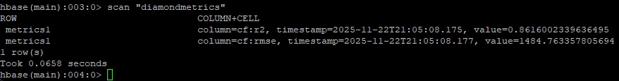
From here we can see that the pipeline functioned as intended. Each step was validated along the way as being successful.

Issues
I did run into several issues when trying working on the pipeline. I had originally intended to use all of the features from the data set but could not figure out how to get one-hot encoding to work in the sparkml api. This required me to go into another direction with the algorithm. I also had an issue where Hive did not properly read in the data because of a space in a place where it shouldn’t be.
I also noticed that the nifi flow processer does not have an overwrite option. So if the file already exists it throws an error.

Conclusion
While I did have some knowledge gaps with the sparkML api the project overall went well. The results seem reasonable. I did learn quite a lot about Nifi that will help at work with our ETL processes.

Appendix

All Code and commands used in this project are attached below.

